Comprehensive Assessment:

Online Shopping

Overview

It is a website for the IT Company which delivers various categories of products. The main tabs in this website are Home Page, Category page, Contact Us Page, About, Customer Login, Customer Sign Up, Admin Log in and many which are required.

**System Specifications**

Hardware Requirements:

* PC With 8Gb Ram

Software Requirements:

* Azure Cloud Setup
* Dot Net
* Java Script
* HTML
* CSS
* Azure Databases

The steps followed and technologies used for those are mentioned below. As to build website we required front end, backend and database

1. For Front End (Html, CSS, Bootstrap, React)
2. For Back End (Dot Net, Python)
3. For Database (Azure Cloud)

**Overview of Technologies**

Microsoft .NET:

.NET is a free, cross-platform, open source developer platform for building many different types of applications.

With .NET, you can use multiple languages, editors, and libraries to build for web, mobile, desktop, games, and IoT.

HTML:

HTML (Hypertext Markup Language) is the code that is used to structure a web page and its content. For example, content could be structured within a set of paragraphs, a list of bulleted points, or using images and data tables

CSS:

Cascading Style Sheets (CSS) is a style sheet language used for describing the presentation of a document written in a markup language such as HTML.

Backend:

For back end I used SSMS(Microsoft SQL) as a database for the data and Asp.net Web Application template. For storing data in local I used SSMS and CosmoDB for storing data in cloud.

JavaScript:

JavaScript is a new scripting language for WebPages. Scripts written with java script can be embedded into your HTML pages. With java script you have many possibilities for enhancing your HTML page with interesting elements. For example you are able to respond to user-initiated events quite easily. Some effects that are now possible with java script were some time ago only possible with CGI. So you can create really sophisticated pages with the helps of java script on the Internet.

In the azure I used Azure Traffic Management for the website and Virtual Machines for employees

And also included Azure Cloud computing services and Data gateway

Azure Cloud Services:

There are many cloud services in azure I used SQL Database, Virtual Machine, App Services, Azure Traffic Manager for this project .

* Azure SQL Database is a fully managed platform as a service (PaaS) database engine that handles most of the database management functions such as upgrading, patching, backups, and monitoring without user involvement.
* Azure Virtual Machines (VM) is one of several types of on-demand, scalable computing resources that Azure offers. Typically, you choose a VM when you need more control over the computing environment than the other choices offer.
* Azure Web Apps are Microsoft's offering to cloud to host web applications. It allows developers to focus on delivering business values rather than consuming time on Sever updates or OS patches. Interestingly, applications built on Java, PHP, Python or Node. js can also be deployed on web apps.
* Azure Traffic Manager is a DNS-based traffic load balancer. This service allows you to distribute traffic to your public facing applications across the global Azure regions. ... Azure provides a suite of fully managed load-balancing solutions for your scenarios.

Below are the steps in creation of virtual machine

The virtual machine resource page look like

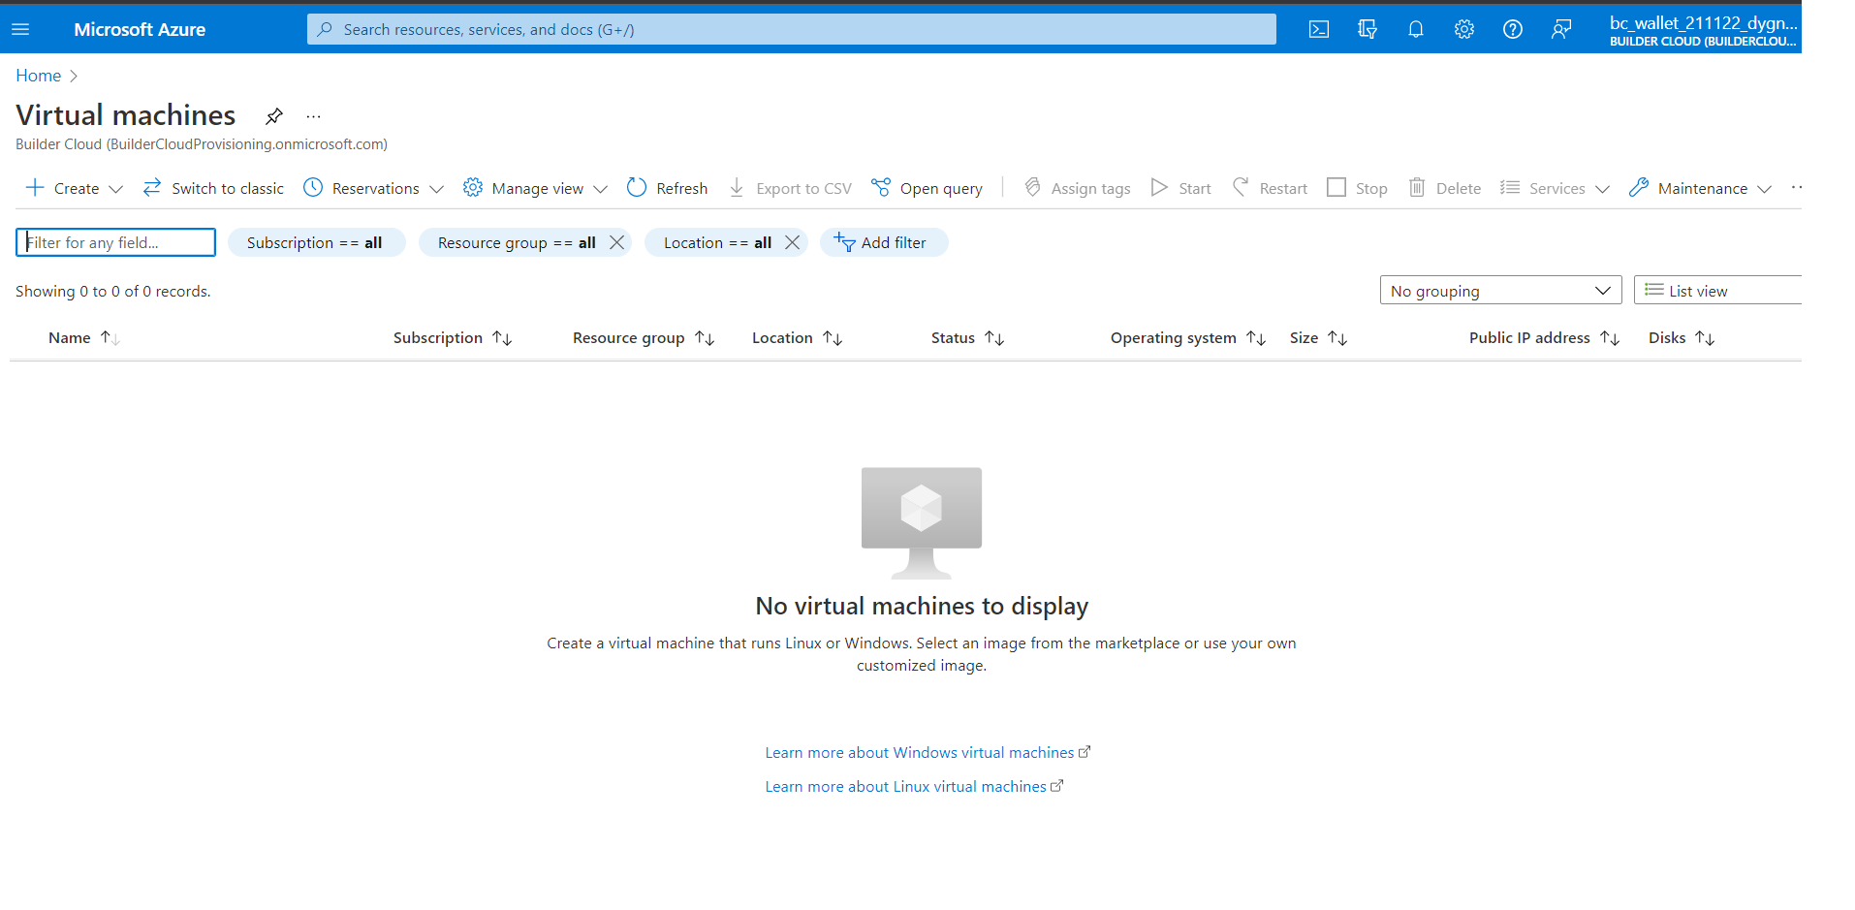

Now click on the create button in order to create new virtual machine

Then it asks some mandatory details fill those details in basic tab

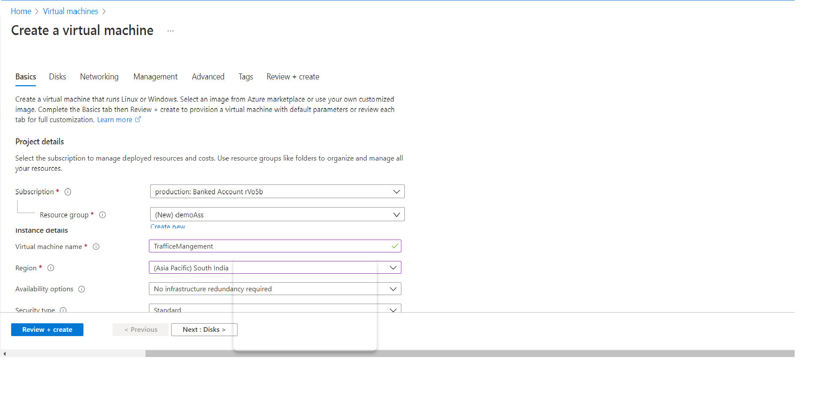

Coming to Disks tab it look like

Based on the usages we can use the size of the disk storage

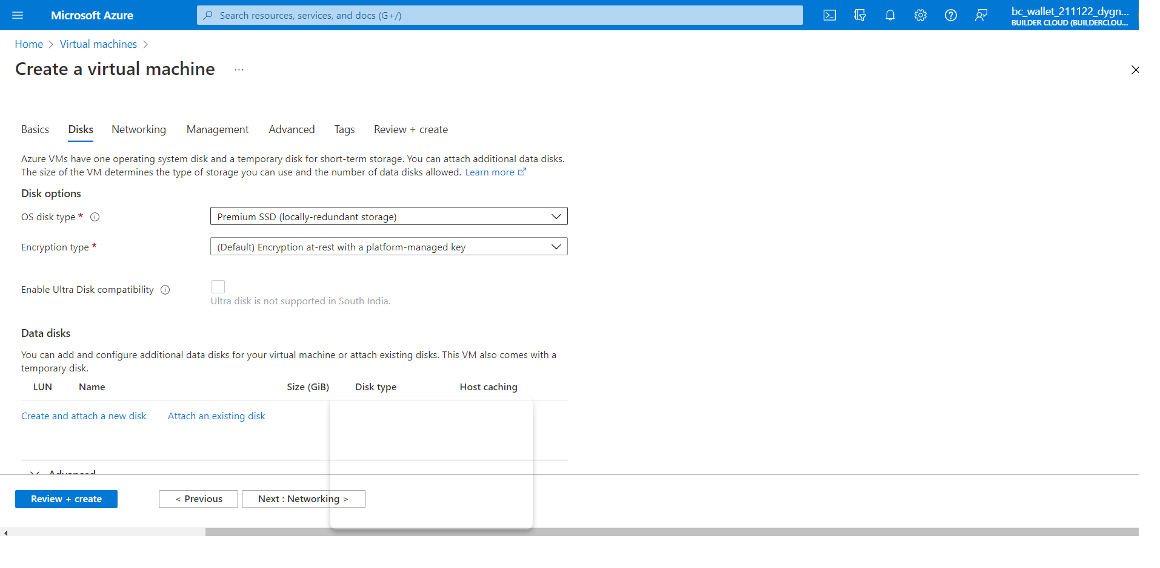

To deploy our web application we required App services. So lets create web app in azure resources

The below image is the web app service

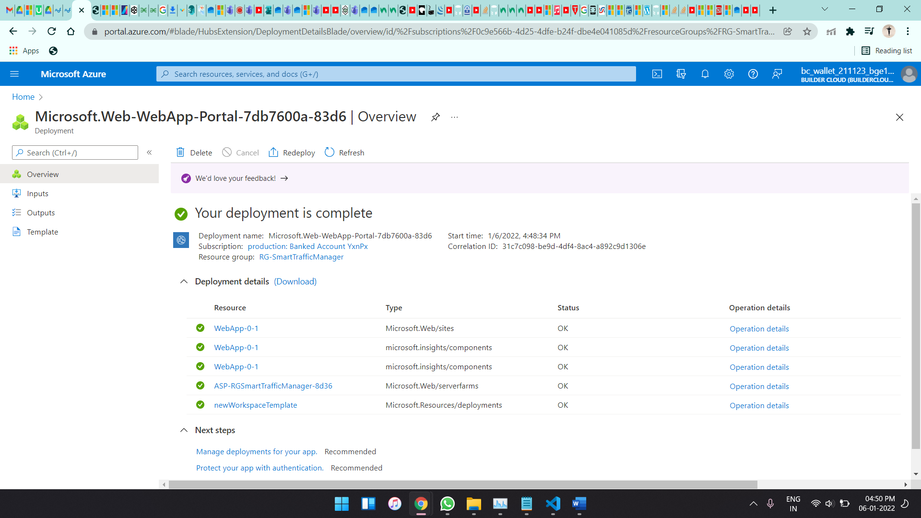

Then we need to manage this with the azure traffic manager

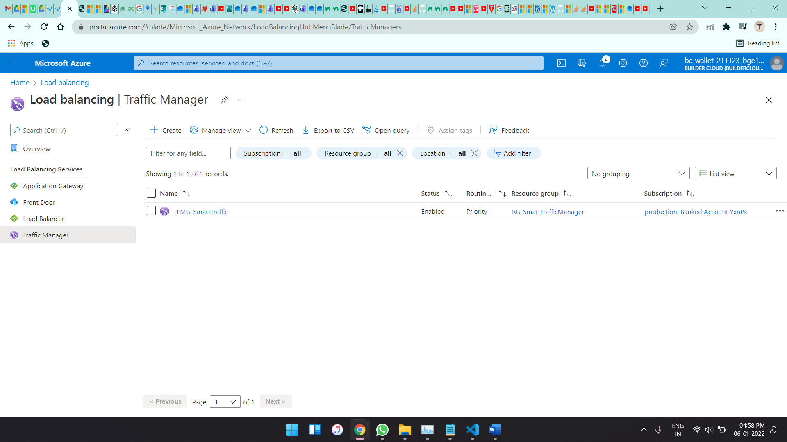

The above image is the dashboard of the azure traffic manager

Now with the web application part

The core Modules are

* Admin
* Products
* Customer

Admin:

Admin get all access like Admin can add new Categories in products in the same way admin can also delete that category and also products in that particular categories.

Products:

This module contains product name, and related image, and cost of it and also product description for the products like mobiles, laptops, bags, etc. whatever customer wants from the shopping store.

I used .NET framework Web application template

In that I used MVC stands for Model View Controller

Model:

* Model represents the data
* Model represents the shape of the data. A class in C# is used to describe a model. Model objects store data retrieved from the database.

View:

* View is the User Interface
* View in MVC is a user interface. View display model data to the user and also enables them to modify them. View in ASP.NET MVC is HTML, CSS, and some special syntax (Razor syntax) that makes it easy to communicate with the model and the controller.

Controller:

* Controller is the request handler.
* The controller handles the user request. Typically, the user uses the view and raises an HTTP request, which will be handled by the controller. The controller processes the request and returns the appropriate view as a response.

Model Diagram:

The required tables and columns are clearly visible in the below diagram

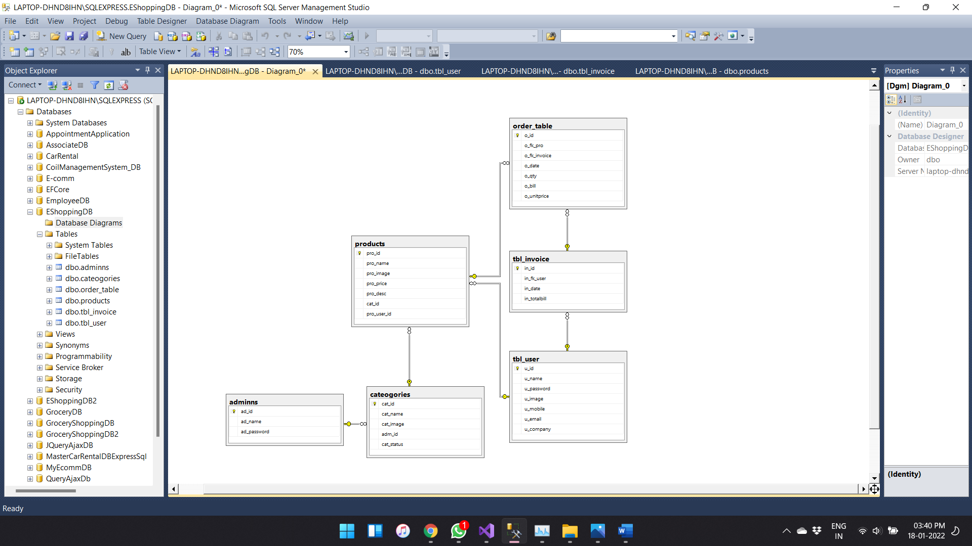

The above figure is from the SSMS database

Index Page:

The home page of our website looks like below

At top the name of the company and logo of that company

Then we have the product Category, About Admin Login Sign up for new Customers and Log in for already existing customers.

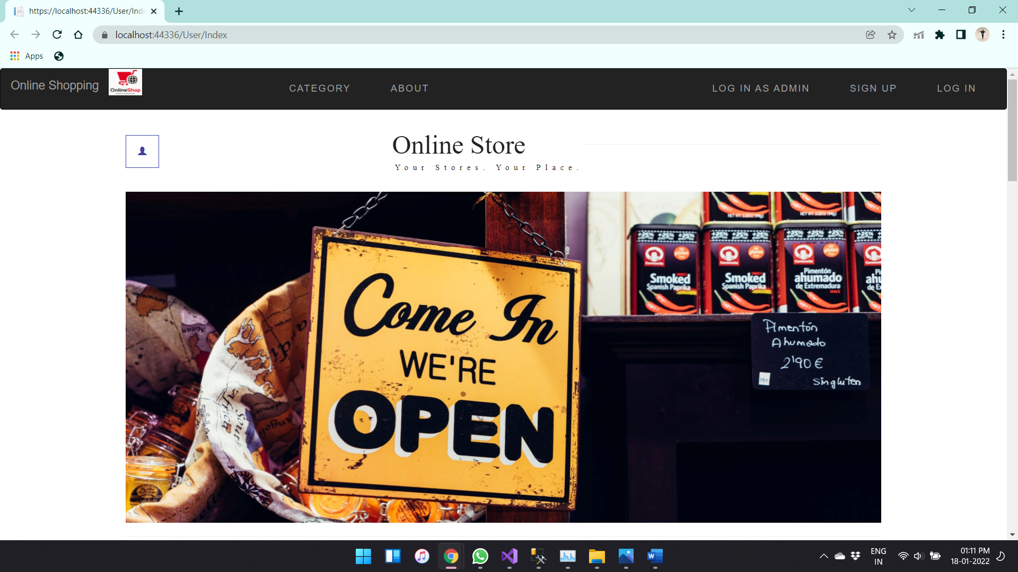

Above image is Home page 1 of 2 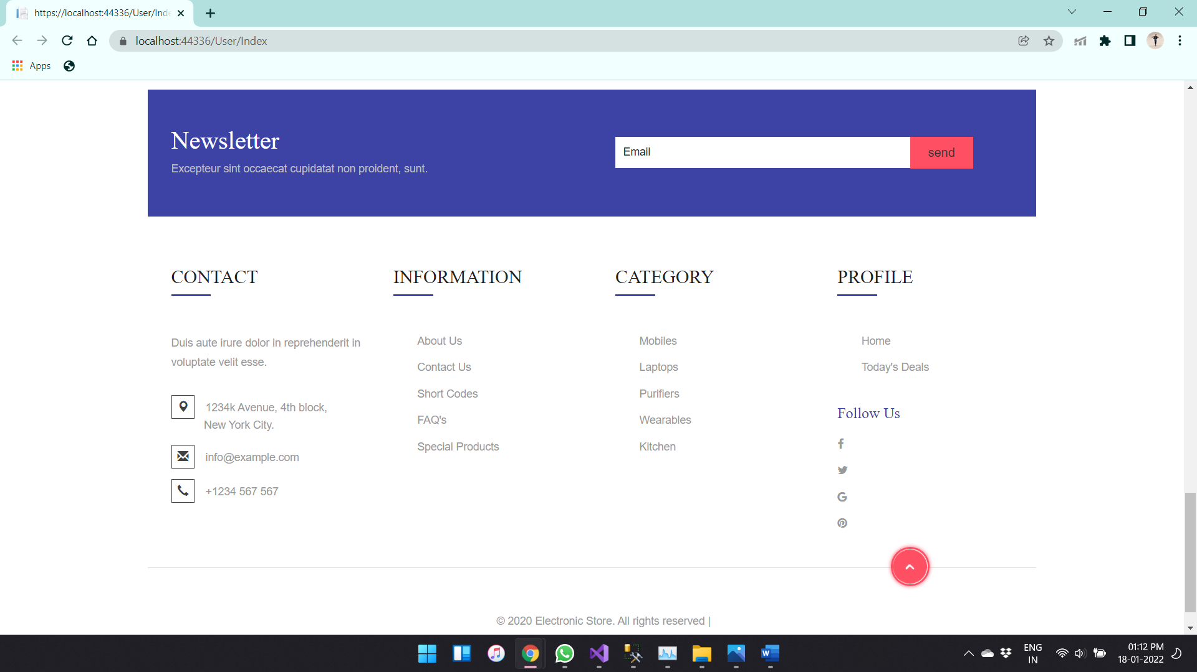

Home page 2 of 2

The above image is the bottom of the home page as it contains company details and Product details

Admin Login page:

In the Admin log in page it asks admin username and password in order to get the access.

The admin log in page is shown below

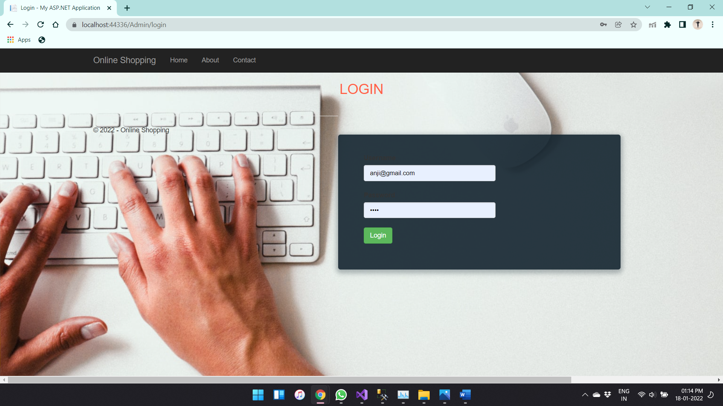

Admin can Add Categories of different products and relevant images of that product category

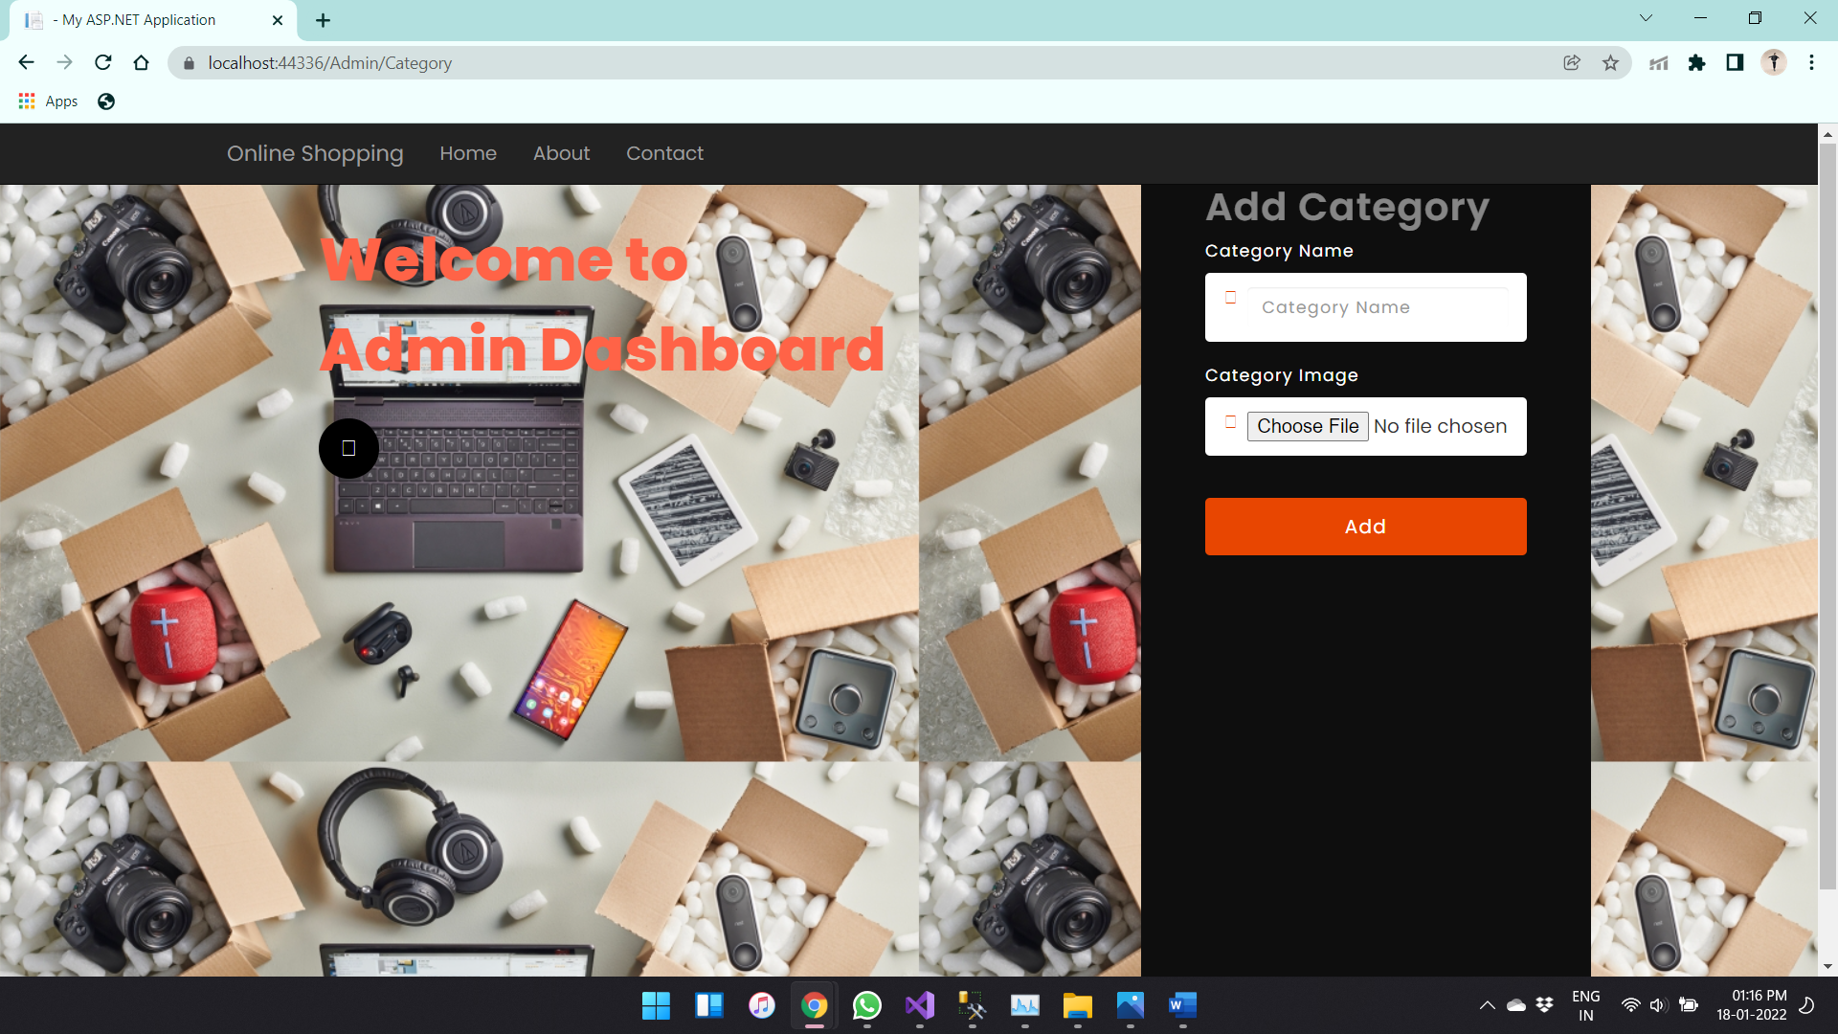

Similarly Admin can have access to delete the Product Categories

I added only 3 Categories with the admin access

The modification of categories is shown below as there is a delete button in order to delete the category.

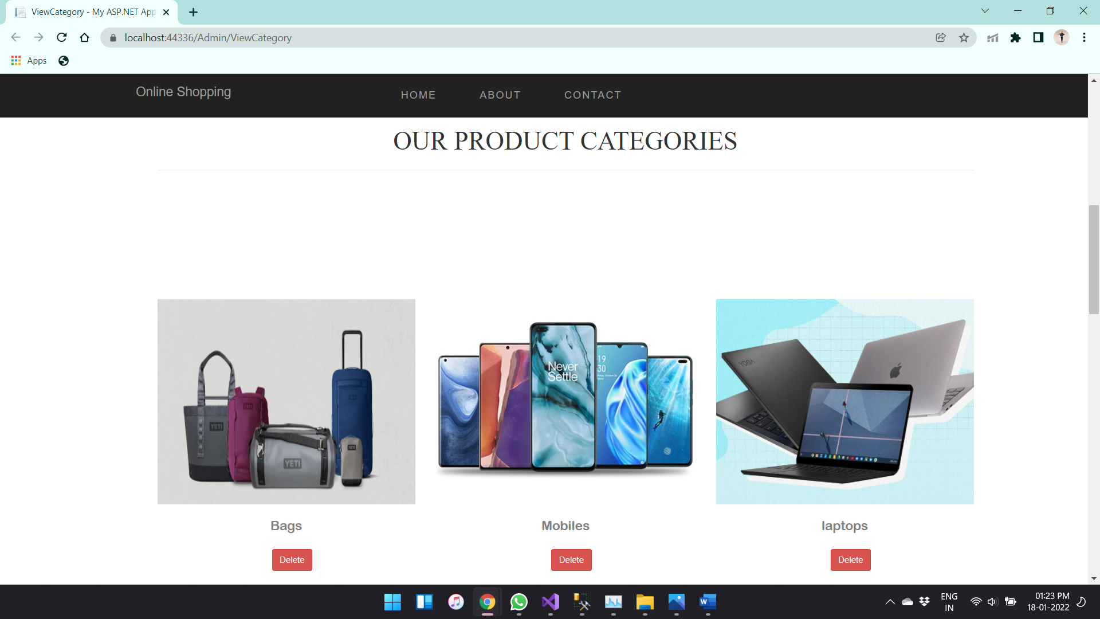

Admin can add or delete the categories

Now the user can sign up by clicking the sign up button in the home page

Then the signup page is shown below

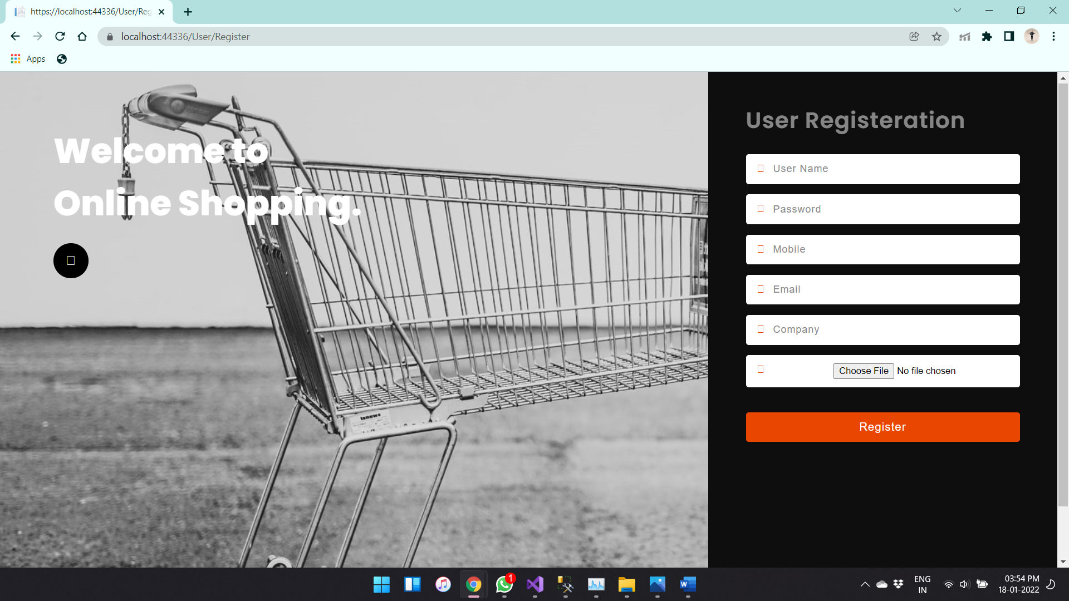

As it asks the customer data like Name, Password in order to login, Mobile number, Email ID, Company Name and that customer profile picture. After entering all details customer need to tap on the register button then the customer details are stored in the user table in database.

The below is the user data table

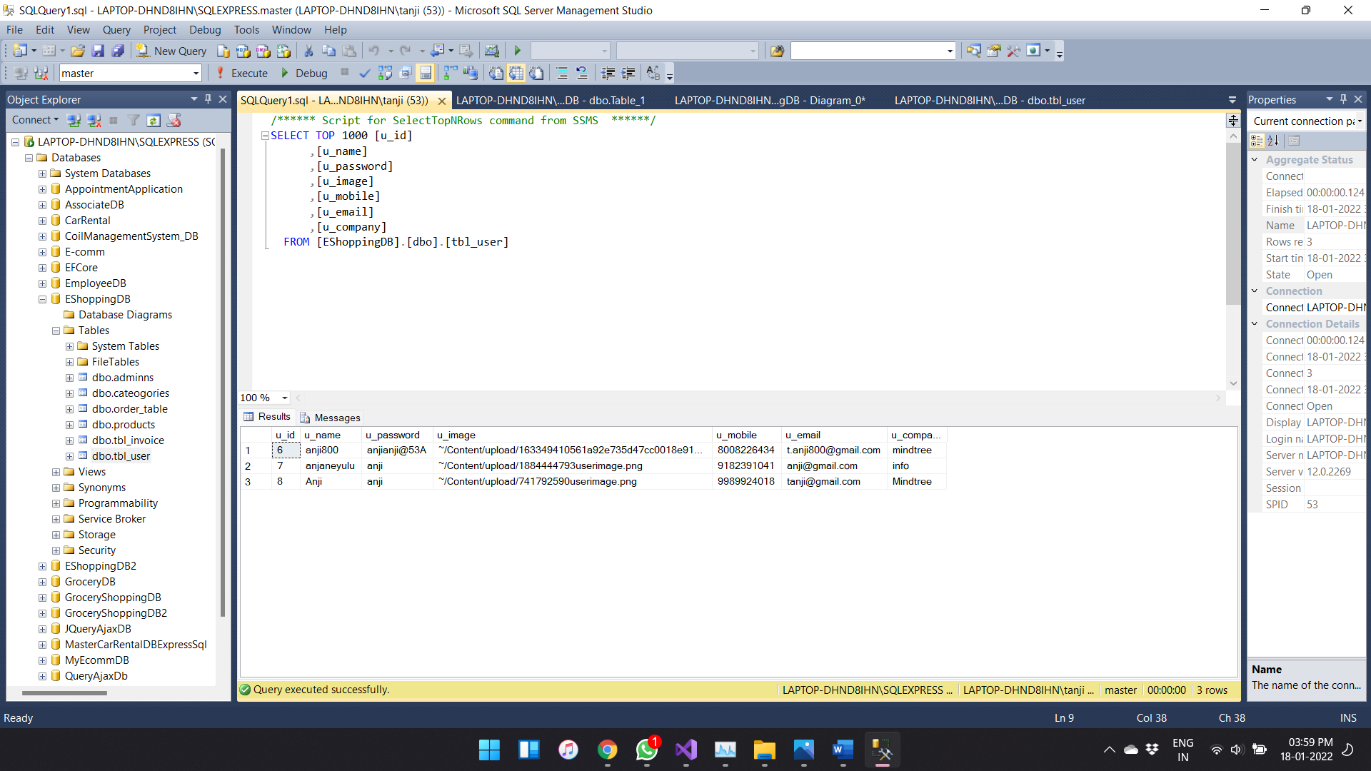

So the user can now log in using the email ID and password

The login page of the User is shown below

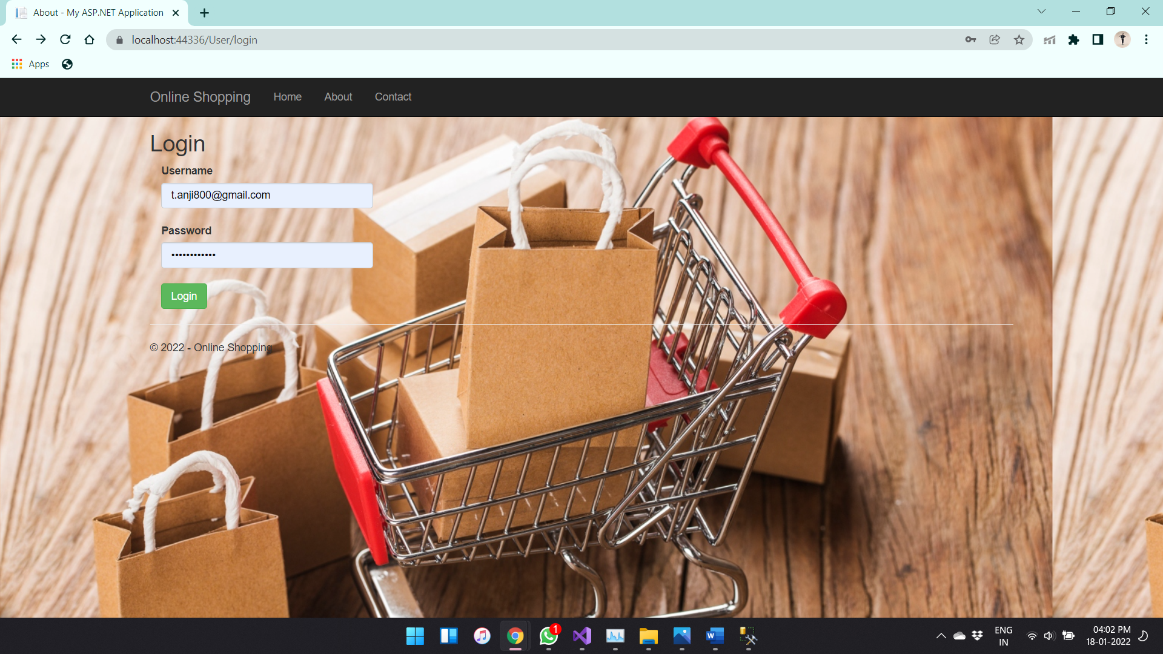

After User Successful login the page redirected to User Home page

This user Home page is shown below

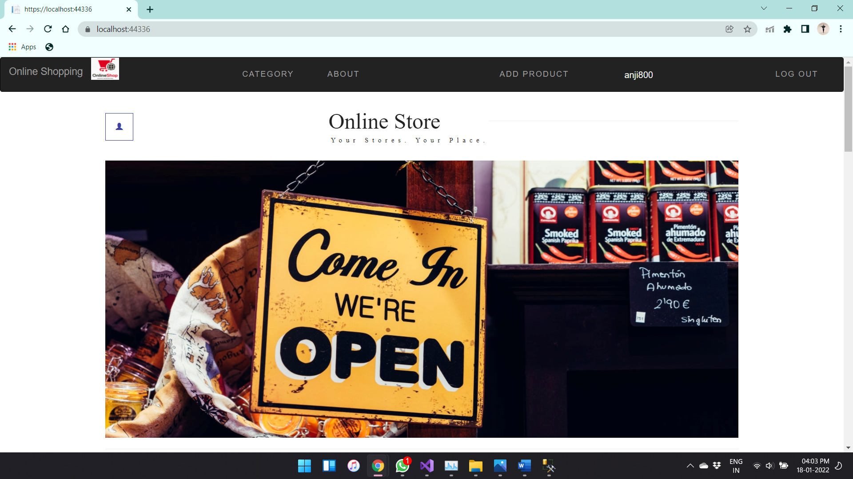

Now the tabs are different as it contains user name at the right of the screen and logout tab

Now the user can select the products that user wants

The category page look like

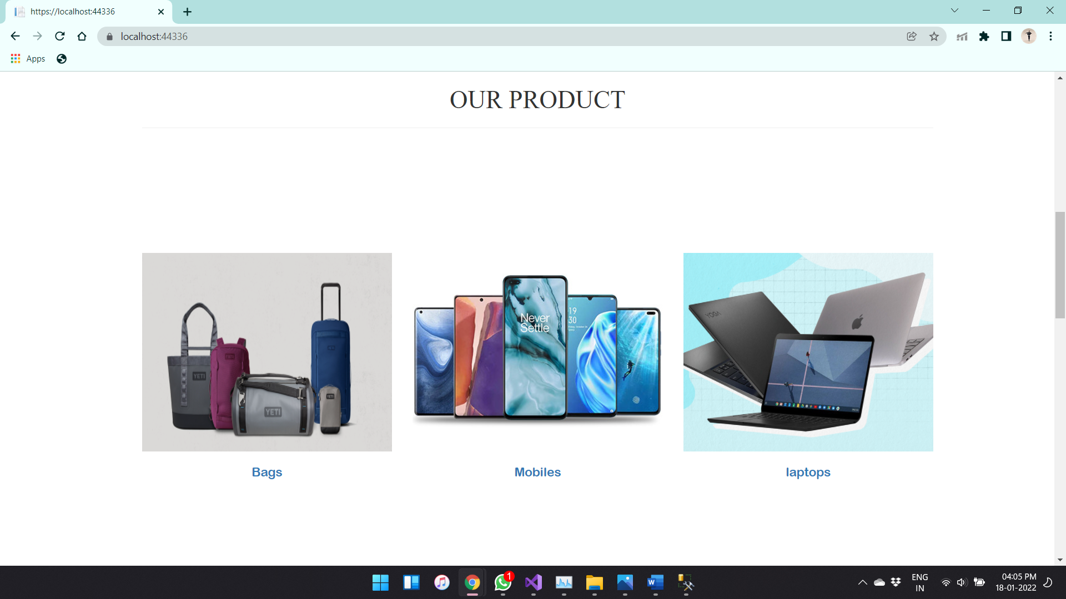

User can select the category after selecting the category the page is redirected to the products page of that particular category

This products page is shown below

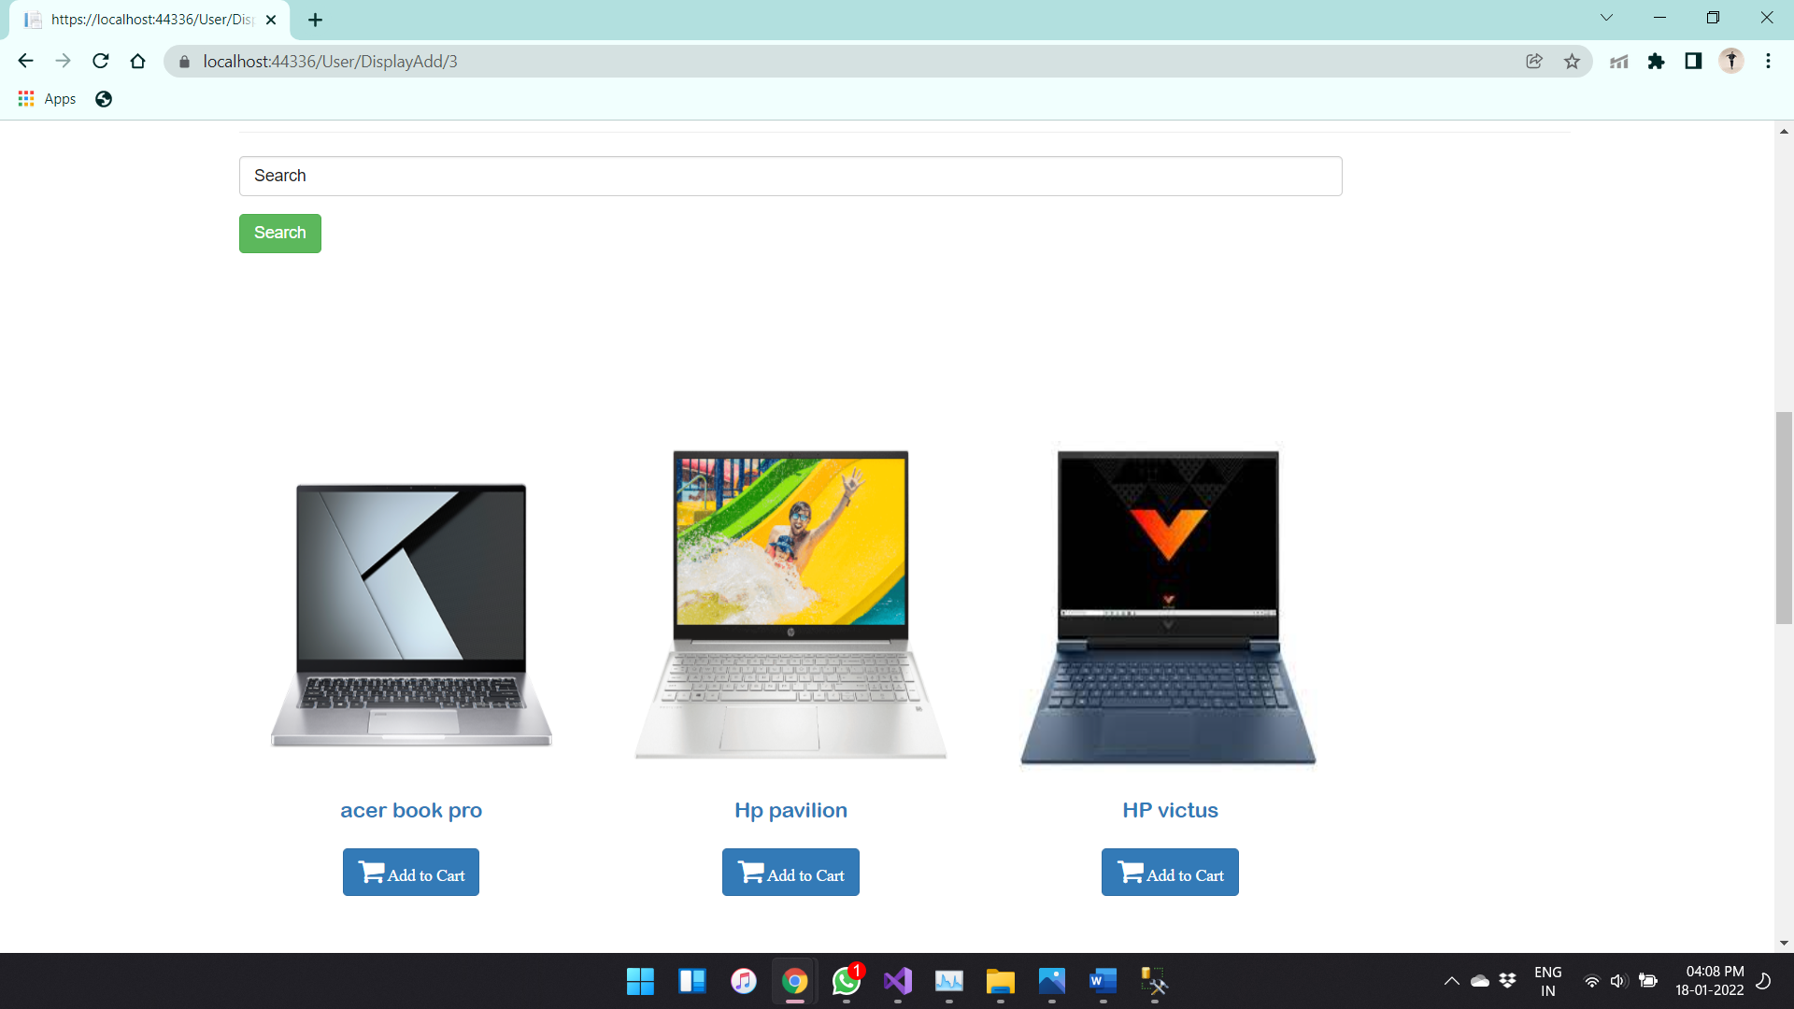

There is a search option in order to search the products the selected products can be added to use cart by tapping on the add to cart button below the product.

Then the page is redirected to product details that contains Name, price, and description of that product this page is shown below

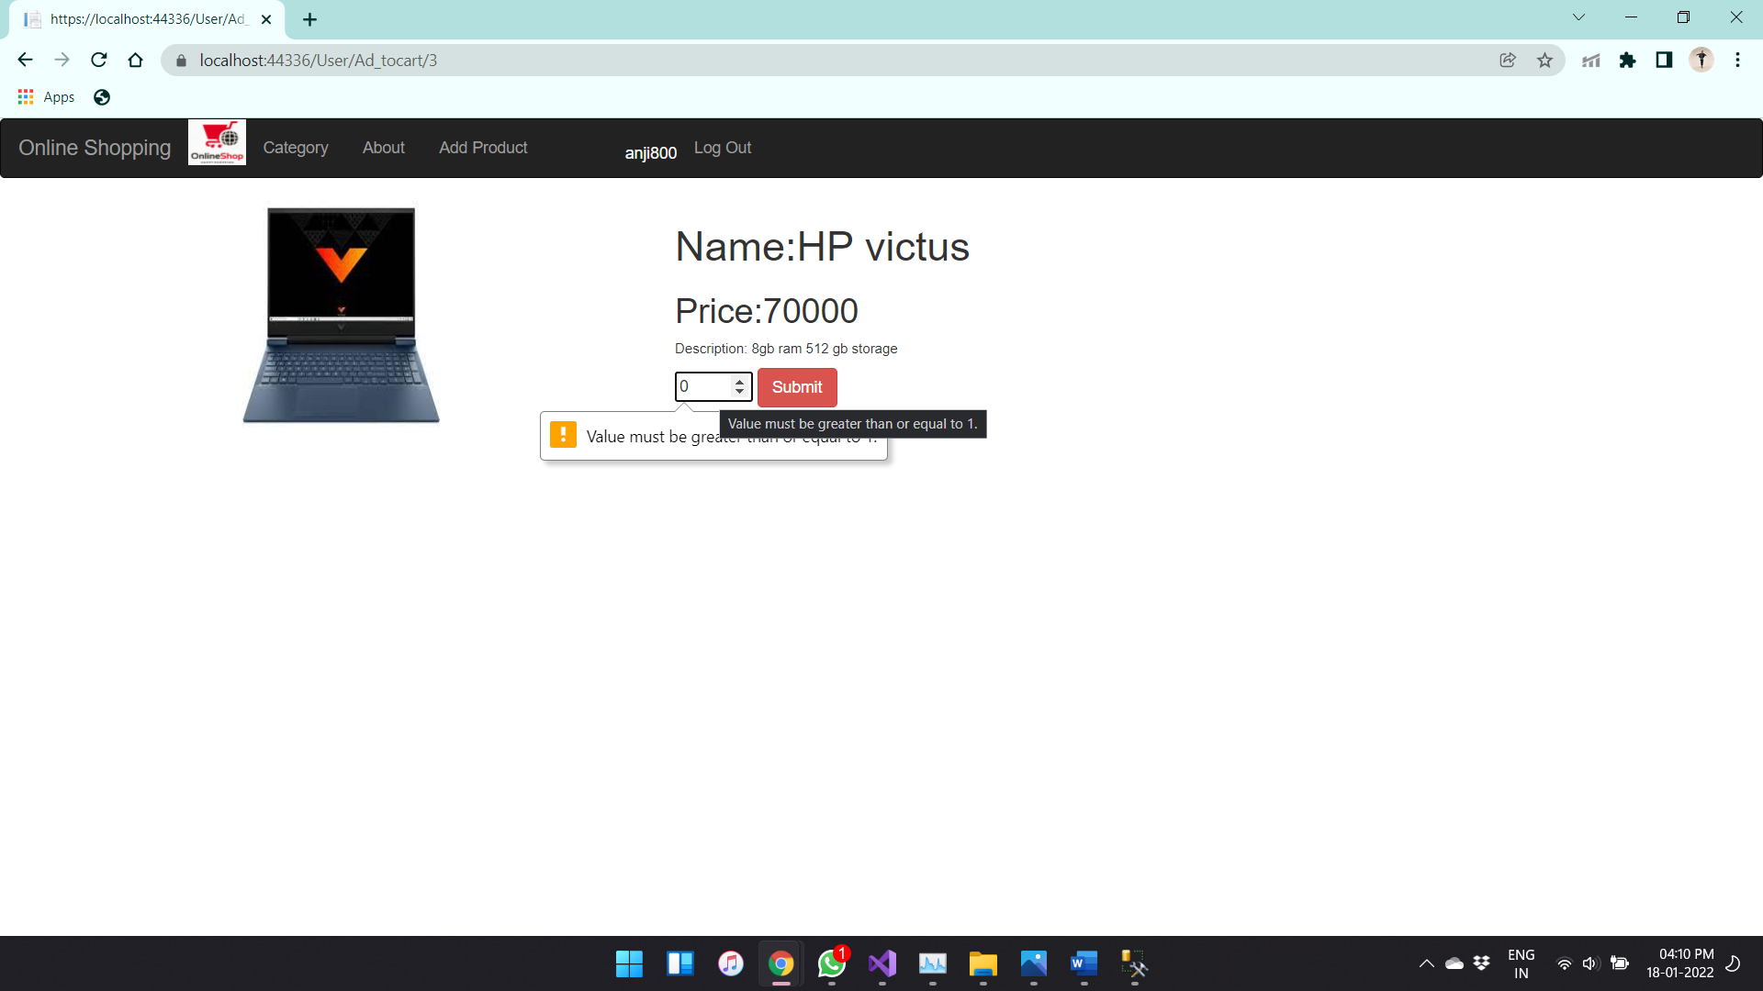

And also the quantity of that product I made validation for the quantity that the user can add minimum of 1 quantity and maximum of 12 quantity.

After adding products to cart the intimation of total bill price of those products in cart is seen from the home page of user its looks like

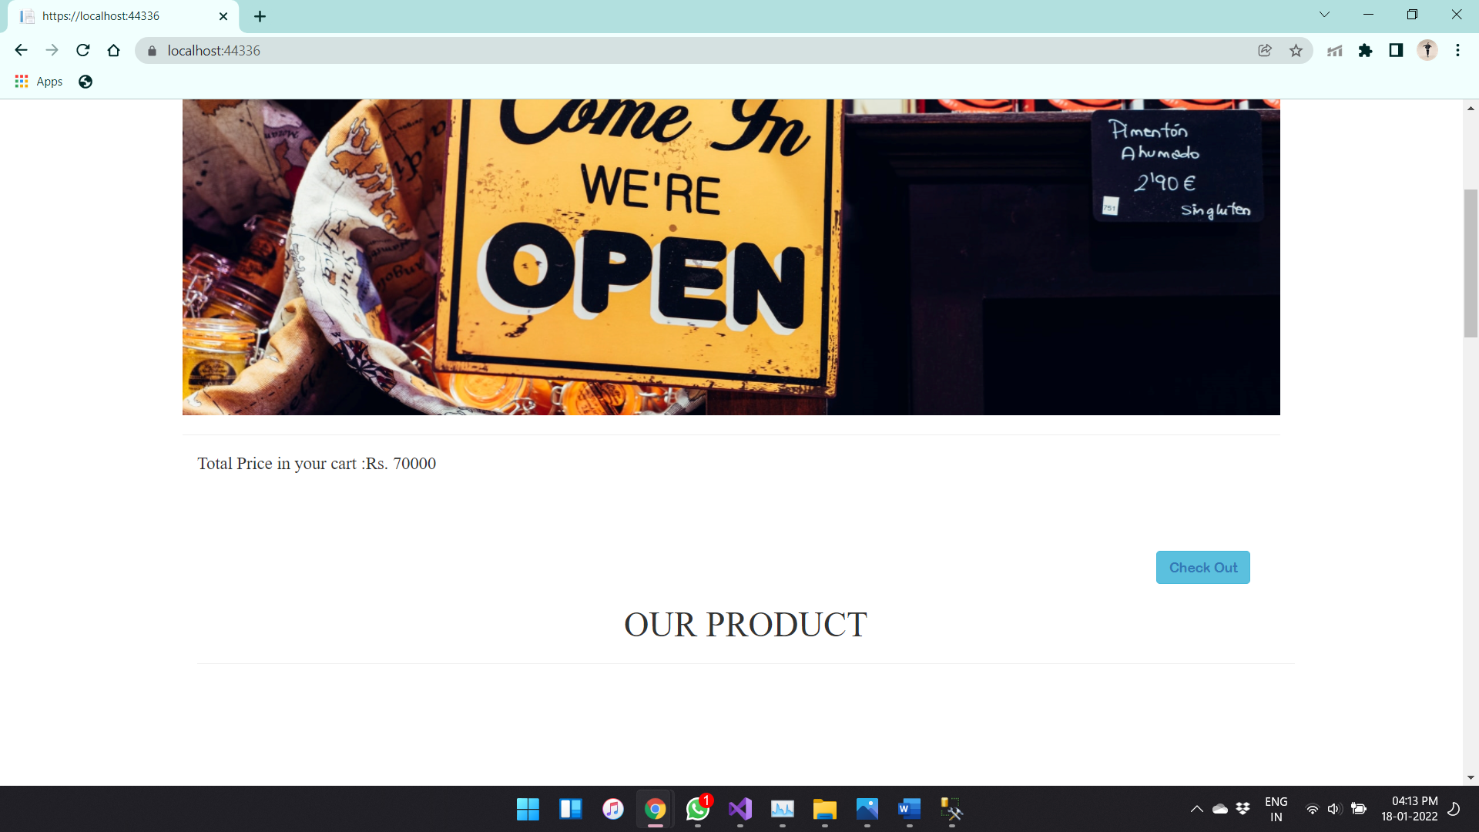

The user can add products to particular category by just tapping on the add product in the user home page this is shown below

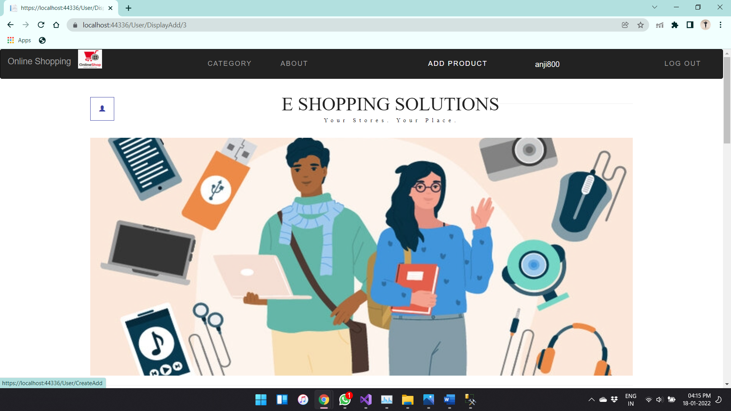

After tapping on the add products the page is redirected to add products page

This page is shown as below

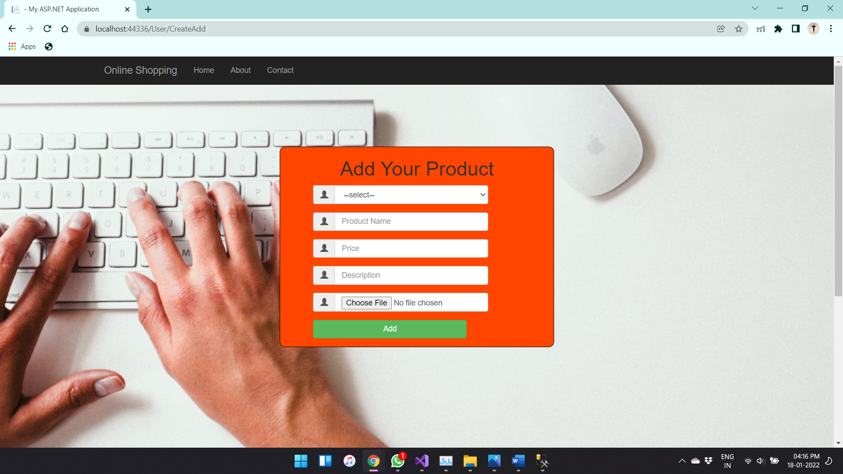

Here the user can add the new products to this showing website the first field shows the categories of different products.

Then we have name of that product, price, Description, and related image of that product.

Then the user can tap the add button to add his product.

In the user home page the check out button is present in order to place order.

This button look like

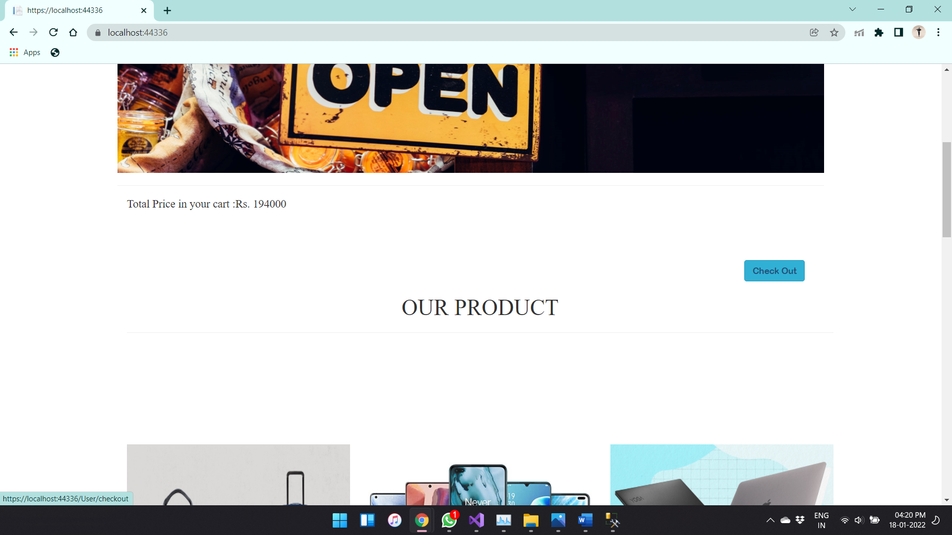

In the check out page the user can place order and the user can also modify the products

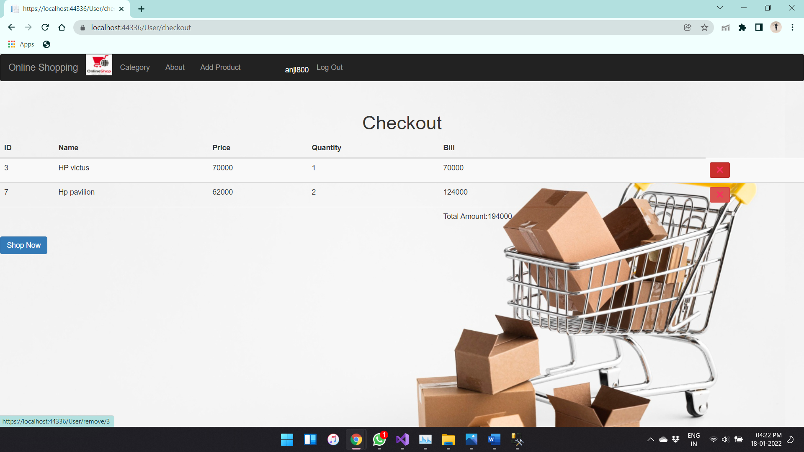

The above image is the checkout page where the user can delete the particular product that user wants if the user is satisfied with the particular product total billing amount in the bottom he can click the shop now button

After user placing order the cart will be empty

The transition successful message is shown

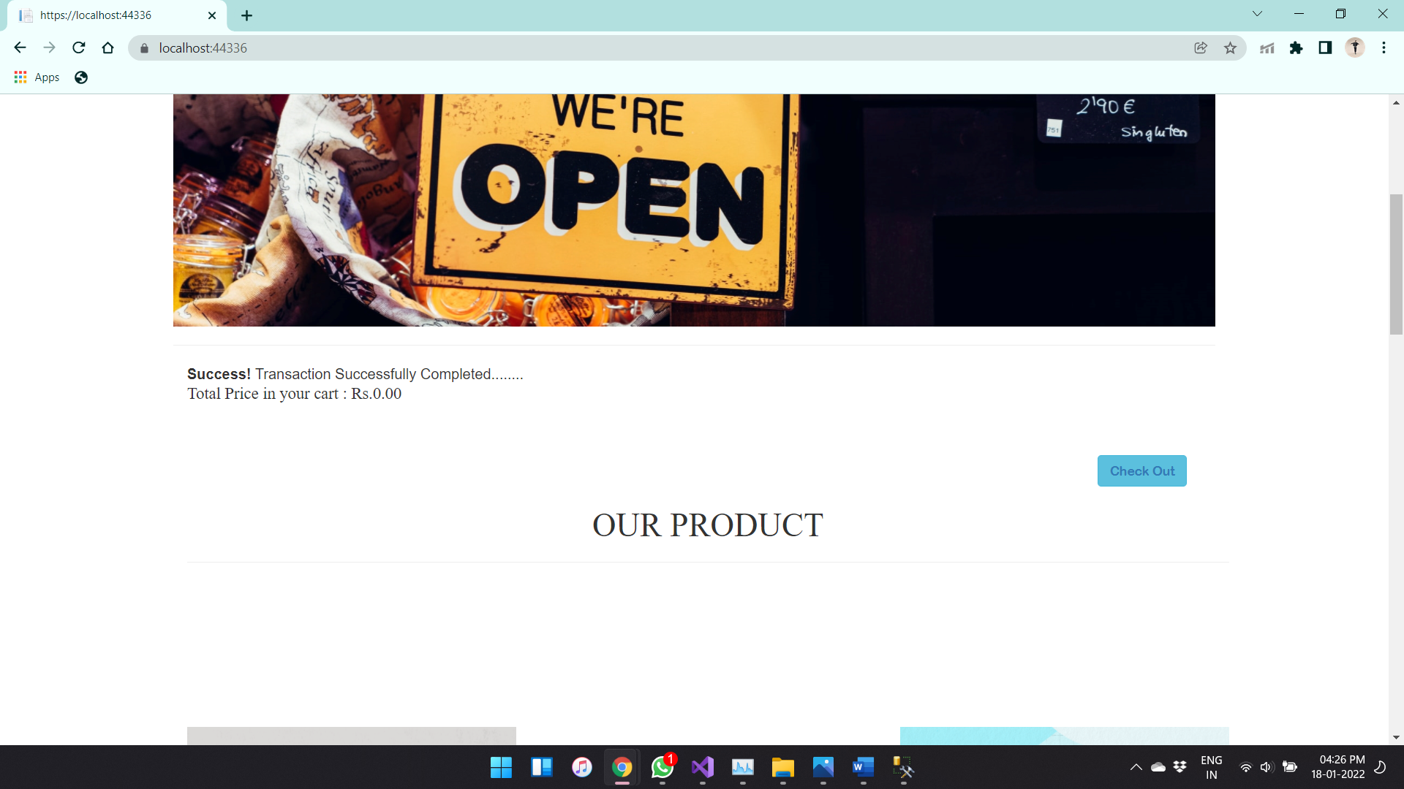

If the user checks the products in the cart will be empty as shown below

So if he wish to place another order he can place by clicking go back button in the cart page as seen in below picture

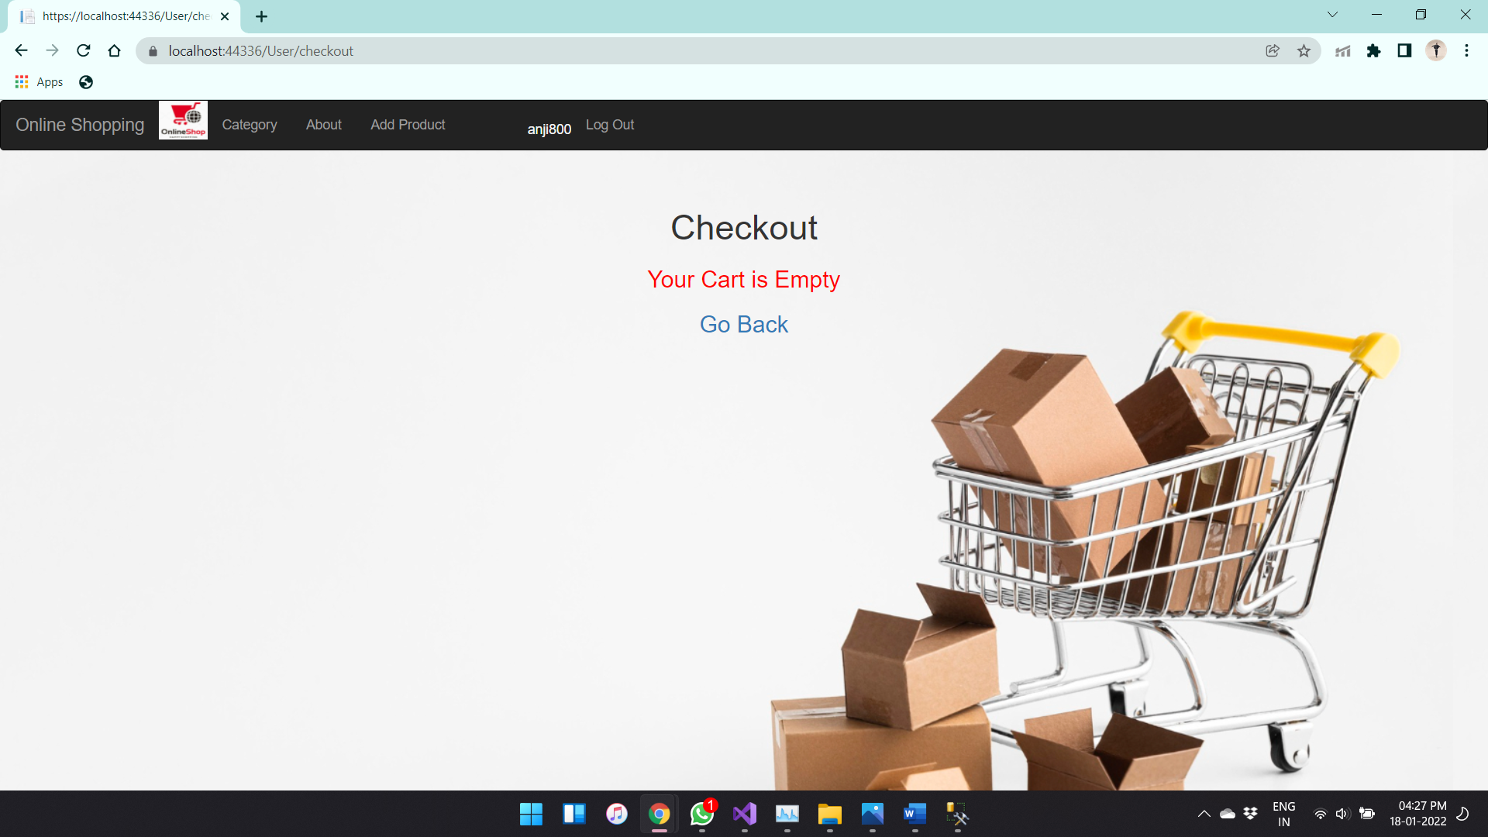

What ever products added by the particular user it can be deleted by the user itself only

This page looks like as shown below

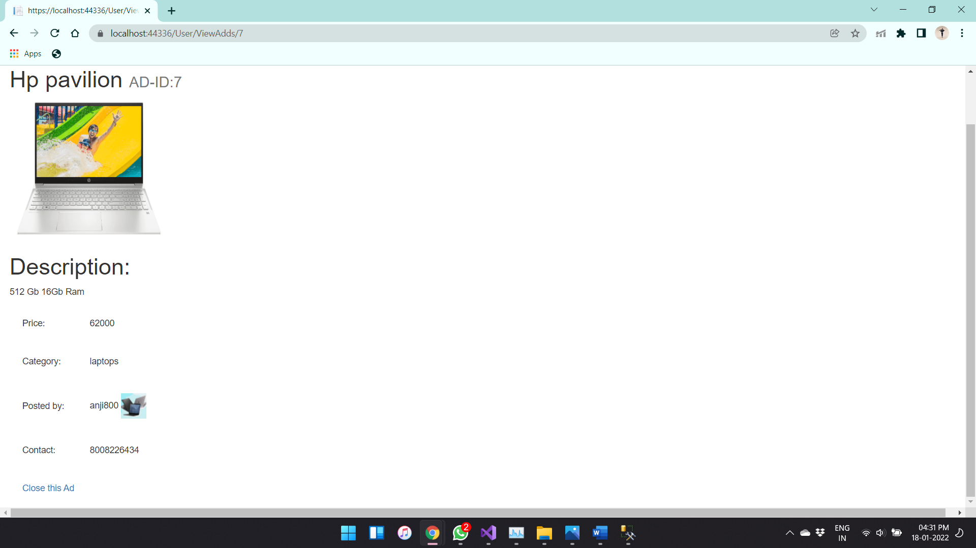

By pressing close the user can close or delete that product from the database and website

The related invoice table date is shown below as it contains the user id ,date time of the order and total bill

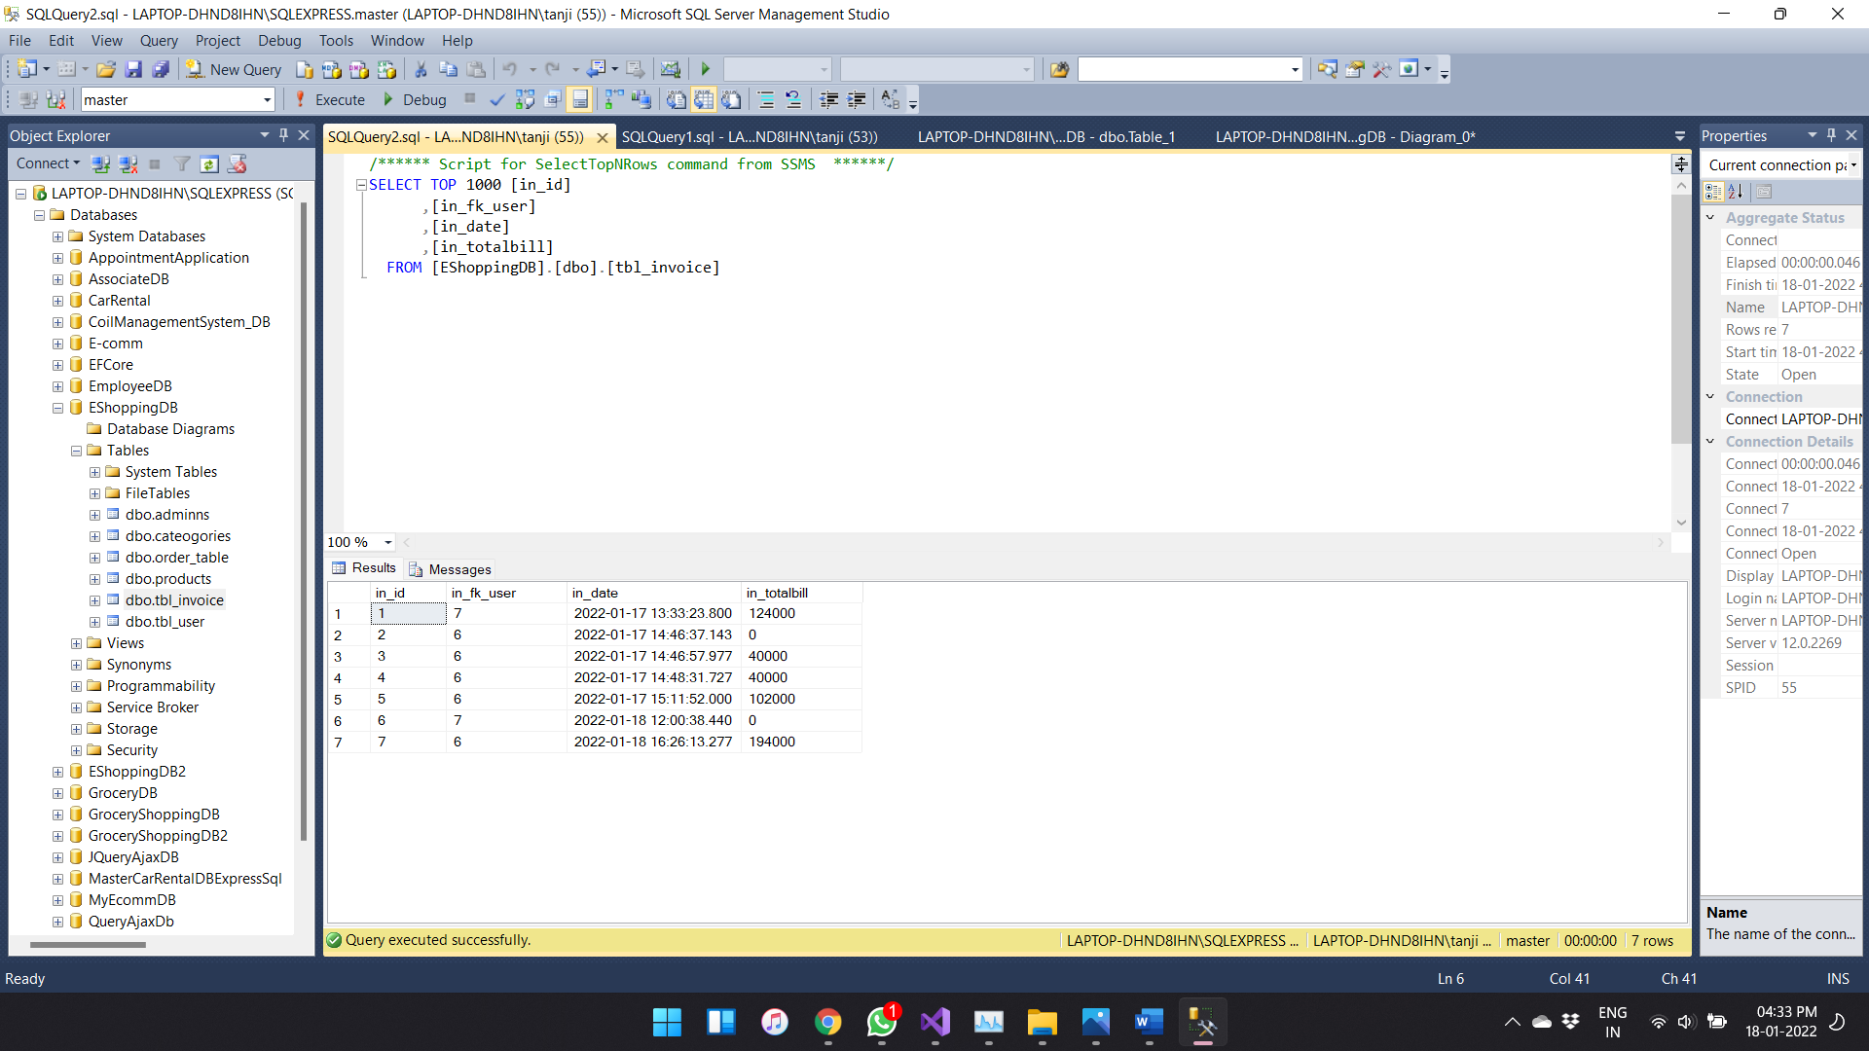

The order table is shown below

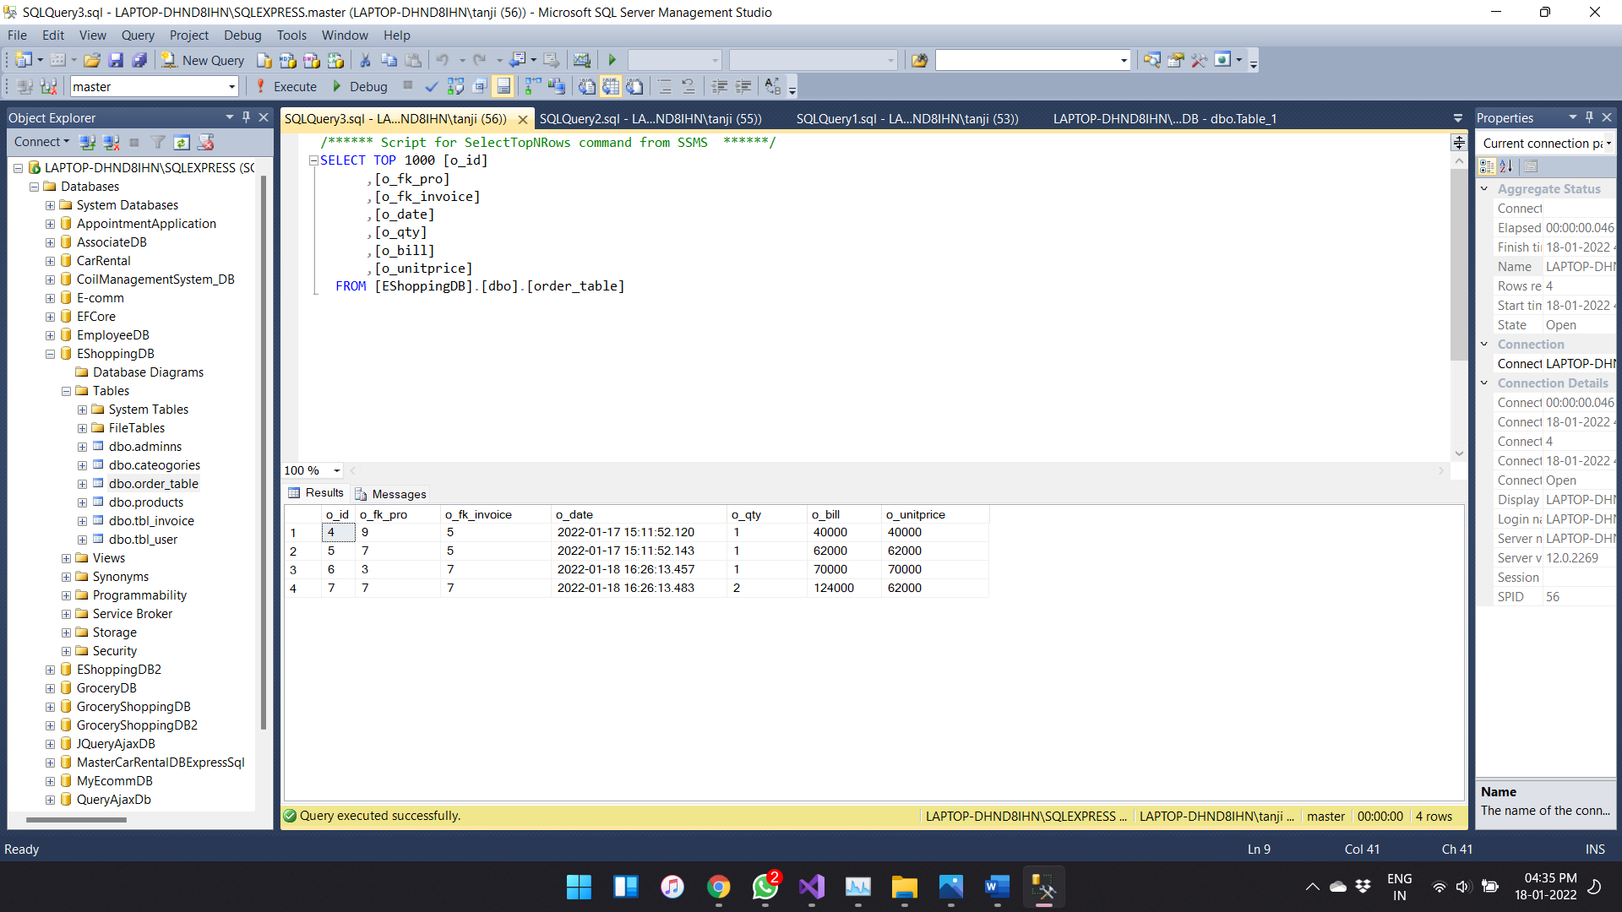

Similarly products table

